A Minor Project Final Report On

Online Placement System
Submitted in Partial Fulfillment of the Requirement for the
Degree of Bachelor of Engineering in Information Technology
Under Pokhara University

Submitted By:
Manisha Shah (CRN:161423)
Prashant Baral (CRN:161428)

Under the Supervision of
Er. Niranjan Khakurel

Date: 12/28/2019


Department of Information Technology
NEPAL COLLEGE OF
INFOMATION TECHNOLOGY
Balkumari, Lalitpur, Nepal

ACKNOWLEDGEMENT
We are thankful to Nepal College of Information Technology for providing us the chance to build software during the minor project and managing the resources and specialists to assist our project. We acknowledge the effort of those who have contributed significantly to our project. Without the support, valuable suggestion and contributions from a number of individual, it would have been impossible for the completion of this project within this duration. A special thanks to our Project Supervisor, Er. Niranjan Khakurel, whose help, stimulating suggestions and encouragement, technical support helped us to coordinate our project especially in writing this report. We are indebted to Head Project Coordinator Dr. Roshan Chitrakar, who is our actual supporter for the action, they have managed, everything a student need.
Aside from these, our thanks and appreciations also go to our colleague in developing the project.
Thank You

Project Members:
Prashant Baral
Manisha Shah

ABSTRACT
The manual work makes the process slow and other problems such as inconsistency and ambiguity on operations. In order to avoid this, web-based placement managed system is proposed, where the student information in the college with regard to placement is managed efficiently. It intends to help faster in procedures of placement related activities and ensures to maintain the details of the student.
The Online Placement System for College consists of a student login, company login and an admin login. The project is beneficial for college students, various companies visiting the colleges for recruitment and even the college placement officers. The software system allows the students to create their profiles and upload all their details including their marks onto the system. The key feature of this project is that it is one-time registration enabled. The admin can check each student details and can remove faulty accounts. The system also consists of a company login where various companies visiting the college can view a list of students in that college and also their respective resumes. The software system allows students to view a list of companies who have posted for vacancy. The admin has overall rights over the system and can moderate and delete any details not pertaining to college placement rules. The system handles student as well as company data and efficiently displays all this data to respective sides.
Keyword: placement, jobseeker, employer, php, mysql, html.

Table of Contents
ACKNOWLEDGEMENT 1
ABSTRACT 2
INTRODUCTION 5
PROBLEM STATEMENT 6
PROJECT OBJECTIVES 7
SIGNIFICANCE OF STUDY 8
LITERATURE REVIEW 9
METHODOLOGY 10
CONCLUSION 14
FURTHER WORKS/RECOMMENDATIONS 15
BIBLIOGRAPHY/REFERENCES 16
APPENDIX 17

List of Figures
- LINEAR SEQUENTIAL MODEL 9
- ER DIAGRAM 13
- USE CASE DIAGRAM 14
- FLOWCHART 15

INTRODUCTION
Nowadays we all are using the internet to do multiple things like booking, academic search, blogging, apply for any job, etc. This system can be used as an application to manage student information to related placement. This system handles student as well as company data and efficiently displays all this data to respective sides. This System do all work regarding placement like collecting student records, secure login and registration of both students and company, notifying eligible students via message, viewing the proper Resume in format.
Computers and Information Technology has a major influence on the society and the society is becoming more and more dependent on technology. Manual processing makes the process slow and other problems such as inconsistency and ambiguity on operations. The proposed system intends user-friendly operations which may resolve ambiguity. In the system, we can store information of students as well as companies. Students can view job vacancy information provided by a company and can apply to a job. On the other hand, company can view the applicant’s (Student’s) information.

PROBLEM STATEMENT
Often the freshers go on to surf internet and social medias to get the information about placement offers. Most students could not find proper and right information. There are a lot of fraud offers we may find in social medias as well as the other websites.
Also the old system required applicants to search through print medias for job opportunity. Then the applicants need to apply for the job using conventional methods (writing a CV, printing it, send it to the company). If the CV is rejected they need to make more CV with updates. Employers need to advertise the vacancies and sort of all applicant details, conduct election procedures and complete formalities.

PROJECT OBJECTIVES
There will be no need of putting up notice or emailing every student about the company coming in college. The students can keep updated themselves through this web application.
- Security
- Saves Time and Efforts
- Avoid fake Entry
- Only eligible students get chance

SIGNIFICANCE OF STUDY
Web based information system are designed to improve existing system. It has user friendly interface having quick authenticated access to documents. It provides the facility of maintaining the details of the students. It will reduce the paper work and utilize the maximum capabilities of the Setup and organization as well as it will save time and money which are spending in making reports and collecting data. It can be accessed throughout the organization with proper login provided.

LITERATURE REVIEW
Placement Support System (IJARCCE) - Rupali Komatwar et.al [2]. Placement Support System is an online application. With proper login provided, this application can be accessed outside as well as throughout the organization. To manage the student’s information with regards to placements, this system can be used as an application by the Training and Placement officers of the college. It is computer-based system which improves the system of whatever information, TPO has to send the students and she or he can inform online. It is more accurate than the use of pen and paper work.
Web Based Placement Management System (IJCSIT)-Anjali V et.al [1]. The main benefit from this project is that one-time registration is enabled. It consumes less paper work and It takes less time. This project is developed with PHP and MySQL. The placement cell allows the companies to view the student’s resumes in selective manner. The placement cell calls the companies to select their students for job via the campus interview. In this project the main modules are: Student, Company, Admin.
Jansen, Jansen and Spink (2005) [3], gave implications for online job seeking and recruiting in their paper on using the web to look for work. The authors focused upon three specific research questions: how do people search for job-related information on the web? How effective are these searches? And how likely are job seekers to find an appropriate job posting or application? The data used to examine these questions come from job seekers submitting job-related queries to a major web search engine at three points in time over a five-year period. Results of their study indicated that individuals seeking job information generally submitted only one query with several terms and over 45 percent of job-seeking queries contained a specific location reference. Of the documents retrieved, findings suggested that only 52 per cent were relevant and only 40 per cent of job-specific searches retrieved job postings.
Ng and Burke (2006) [4], in their study on the next generation at work explored the views, career expectations, and job search behaviors among a sample of business students. The authors conducted a field survey involving 20,771 students across Canada to understand the views of university students on jobs, organizations, careers and perception of their organizations. The study using multiple regression analysis found that cooperative students appear to have more realistic expectation, have better insights into their own abilities and desires, and report higher self-confidence. It also reported that the respondents had low expectations that their campus career offices would get them a job, and expected to use the internet more frequently in their job searches. This suggested a shift away from traditional recruitment mediums to more contemporary approaches such as internet.

METHODOLOGY
Software methodologies are concerned with the process of creating software - not so much the technical side but the organizational aspects. Several software developments approaches have been used since the origin of information technology. The project has been developed using linear sequential model of system development which contains all the steps of linear sequential method of System Development Life Cycle. The Linear sequential model or the waterfall model is a sequential design process used in software development process, in which progress is seen as flowing steadily downwards (like waterfall) through the phases of requirement specification, system design implementation, verification and test, system deployment, software maintenance. The waterfall model is a model which was developed for software development; that is to create software.

1. Problem Identification & Data Collection
2. Analysis and Feasibility Study

7. Maintenance

6. Implementation

3. System Design

5. Testing
4. Coding

Fig: Linear sequential model

- ER Diagram:
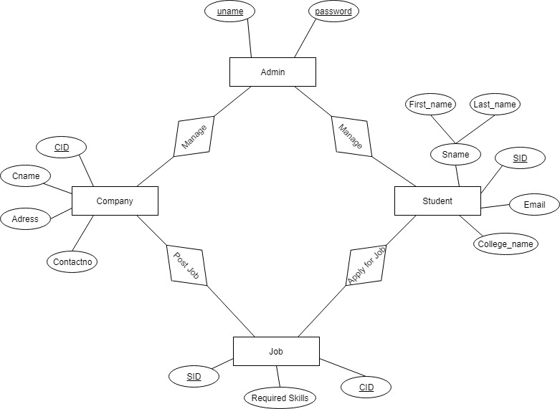

Fig: ER Diagram

- Use Case Diagram:

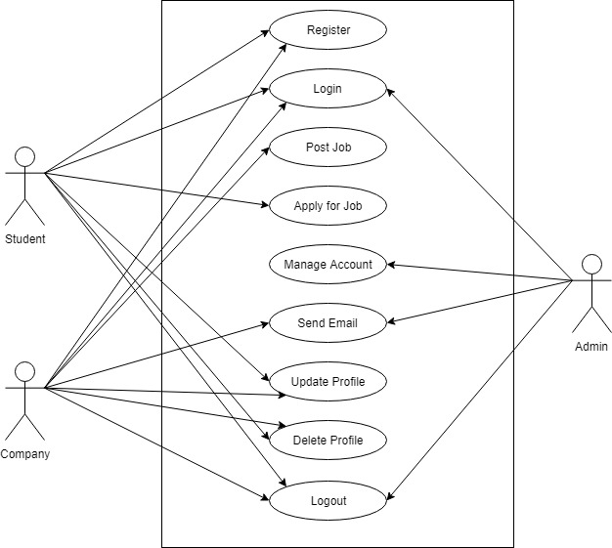

Fig: Use Case Diagram

- Flowchart:

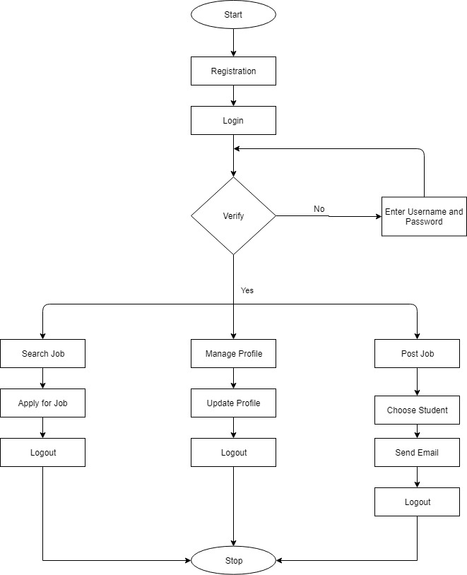
Inform Student

Fig: Flowchart

WORKING PROCESS
The Online Placement System is comprised of three modules: Jobseeker, Employer and Admin.
- Three Modules of this System:
JOBSEEKER
- Student registers in the system with all information we need in a CV such as Academic Info to Documents like Citizenship, etc.
- Student can search for a desired Job and can Apply for that Job.
EMPLOYER
- Employer can register and login into the system.
- Employer can Post the Vacancy for a job or internship.
- Employer can Choose an Eligible Student and Inform them.
ADMIN
- Admin manages the System.
- Admin can delete Fraud Account.

CONCLUSION
At last it can be concluded that, the Online Placement System is made user friendly and simple to use by Jobseekers and Employers. This system is based on PHP and MySQL. This system could help minimize the manual system of seeking job and applying for one. Because of this the online placement system is assumed to be of greater importance. The system can be redesigned by adding more variations and enhancements.

FURTHER WORKS/RECOMMENDATIONS
This system is designed in such a way that following enhancements can be inserted:
- Online Exams can be Allowed.
- Automated E-mail sending system can be implemented.
- Forum can be Implemented.
- Online Chat system can be Implemented.

BIBLIOGRAPHY/REFERENCES
[1] Anjali.V, Jeyalakshmi.PR, Anbubala.R, SriMathura devi.G, Ranjini.V, “Web Based Placement Management System”, International Journal of Computer Science and Information Technologies, Vol. 7 (2), 760-763, 2016.
[2] Rupali Komatwar, Swapnil Kamble, Mihir Khedekar, Kishor Walzade, “Placement Support System ” International Journal of Advanced Research in Computer and Communication Engineering, Vol. 5, Issue 1, January 2016 Vol. 5, Issue 1, January 2016.
[3] Jansen, B.J., Jansen, K.J., and Spink, A. (2005), “Using the Web to Look for Work- Implications for Online Job Seeking and Recruiting Internet Research” Journal of Internet Research, Vol. 15 No. 1, pp. 49-66.
[4] Ng, E.S.W., and Burke, R.J., (2006), “The Next Generation at Work – Business Students’ Views, Values and Job Search Strategy Implications for Universities and HR Managers”, Education + Training, Vol. 48 No. 7, pp. 478-492

APPENDIX
